Another way of using collections is to summarize or aggregate over them. For example, the <$Scr_Cs::2>average<!$Scr_Cs::2> function computes a single number from an entire collection of numbers — as do many of the other statistical functions. We can define <$Scr_Cs::2>average<!$Scr_Cs::2> using the standard <$Scr_Cs::2>leftFold1<!$Scr_Cs::2> function, which is part of the standard <$Scr_Cs::2>folding<!$Scr_Cs::2> contract:
<$Scr_Ps::0>average(C) is leftFold1((+),C)::float/size(C)::float
<!$Scr_Ps::0>Notice the use of coercion here — coercing both the result of the <$Scr_Cs::2>leftFold1<!$Scr_Cs::2> and <$Scr_Cs::2>size<!$Scr_Cs::2> to float. The reason for doing this is that functions like <$Scr_Cs::2>average<!$Scr_Cs::2> are ‘naturally’ real functions. Without the explicit coercion, averaging a list of integers will also result in an <$Scr_Cs::2>integer<!$Scr_Cs::2> value — which is likely to be inaccurate.
Of course, in our definition of <$Scr_Cs::2>average<!$Scr_Cs::2> we need to coerce both the numerator and denominator of the division because Star does not have implicit coercion.
The <$Scr_Cs::2>leftFold1<!$Scr_Cs::2> function applies a left-associative binary operator to a collection: starting from the first element and successively ‘adding up’ each of the elements in the collection using the supplied operator.
As we noted above, <$Scr_Cs::2>leftFold1<!$Scr_Cs::2> is part of the <$Scr_Cs::2>foldable<!$Scr_Cs::2> contract. Like the <$Scr_Cs::2>functor<!$Scr_Cs::2> contract, this uses some more subtle type constraints:
<$Scr_Ps::0>contract all c/1 ~~ foldable[c] ::= {
leftFold1:all e ~~ ((e,e)=>e,c[e])=>e.
...
}
<!$Scr_Ps::0>Notice that this contract – which we have not fully written down here – uses quantifiers in two places: once in the contract specification and once in the type signature for <$Scr_Cs::2>leftFold1<!$Scr_Cs::2>. What we are trying to express here is that any implementation of <$Scr_Cs::2>foldable<!$Scr_Cs::2> must allow for a generic accumulator function.
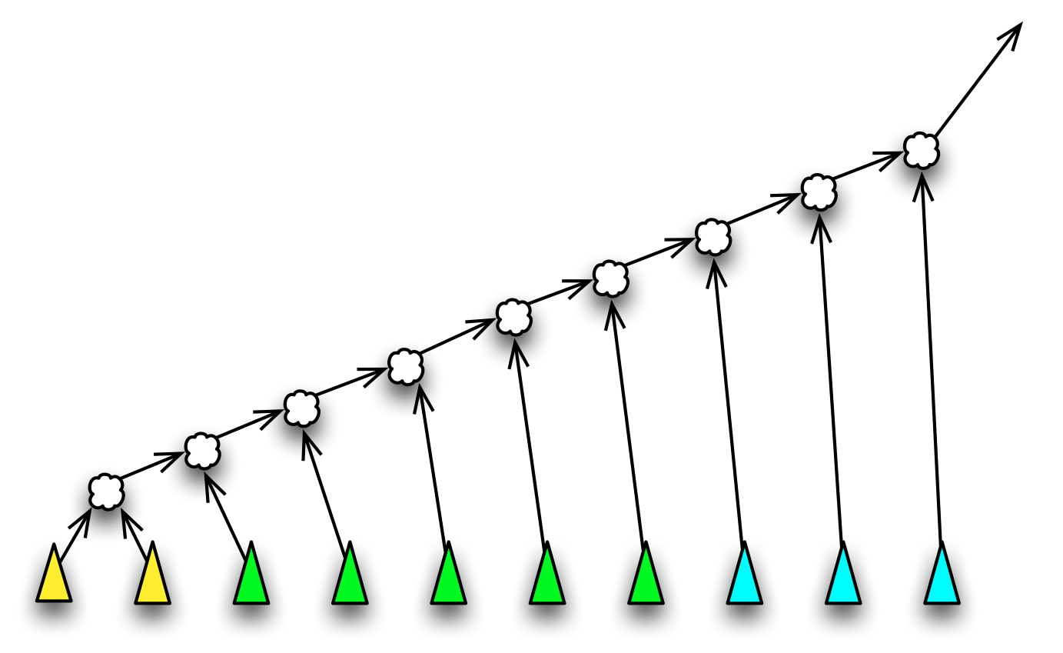
<$Scr_Ps::1>Left Folding a Collection
<!$Scr_Ps::1>Our definition of the <$Scr_Cs::2>average<!$Scr_Cs::2> function is therefore about as close to a specification of average as is possible in a programming language!
While it is convenient for computing averages, there are several restrictions in the signature for <$Scr_Cs::2>leftFold1<!$Scr_Cs::2>: the most egregious is that the result type and the types of the elements of the collection must be identical. A more refined function is possible that liberates us from this:
<$Scr_Ps::0>contract all c/1 ~~ folding[c] ::= {
...
leftFold:all e,ac~~((ac,e)=>ac,ac,c[e])=>ac
...
}
<!$Scr_Ps::0>
<$Scr_Cs::2>leftFold<!$Scr_Cs::2> is also part of the <$Scr_Cs::2>foldable<!$Scr_Cs::2> contract; as are the analogous <$Scr_Cs::2>rightFold<!$Scr_Cs::2> and <$Scr_Cs::2>rightFold1<!$Scr_Cs::2> functions.
In this variant of fold, we separate out an ‘accumulator’ (of type <$Scr_Cs::2>ac<!$Scr_Cs::2>) from the type of the elements of the collection. We saw something similar with the visitor pattern. The <$Scr_Cs::2>leftFold<!$Scr_Cs::2> function applies its argument function in a similar way to <$Scr_Cs::2>leftFold1<!$Scr_Cs::2>, except that it does not require that the type of the accumulator is the same as the elements of the collection. Furthermore, it does not use the first element of the collection as a ‘seed’ of the aggregation — instead, the initial seed is explicitly given.
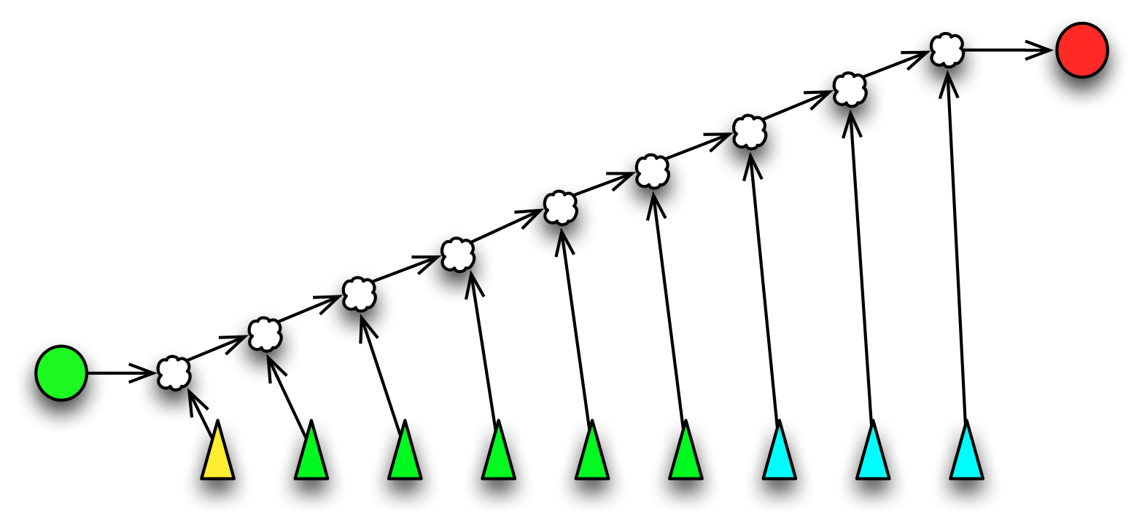
<$Scr_Ps::1>Left Folding a Collection With a Seed
<!$Scr_Ps::1>We can still use <$Scr_Cs::2>leftFold<!$Scr_Cs::2> in situations where we would use <$Scr_Cs::2>leftFold1<!$Scr_Cs::2>, for example our <$Scr_Cs::2>average<!$Scr_Cs::2> function is equally well written as:
<$Scr_Ps::0>average(C) => leftFold((+),0,C)::float/size(C)::float
<!$Scr_Ps::0>But we can do much more than computing averages with a fold. Recall that when we realized the sieve of Erastosthenes, we still had a recursive structure to the program. Furthermore, the way our original program was written each <$Scr_Cs::2>filter<!$Scr_Cs::2> results in a new list of numbers being produced. Instead of doing this, we can construct a cascade of filter functions.
Consider the task of adding a filter to an existing filter. What is needed is a new function that combines the effect of the new filter with the old one. The cascade function takes a filter function and a prime as arguments and constructs a new function that checks both the prime and the existing filter:
<$Scr_Ps::0>cascade:((integer)=>boolean,integer)=>((integer)=>boolean).
cascade(F,K) => (X)=>F(X) && X%K=!=0.
<!$Scr_Ps::0>This is a truly higher-order function: it takes a function as argument and returns a another function.
Given <$Scr_Cs::2>cascade<!$Scr_Cs::2>, we can reformulate the <$Scr_Cs::2>sieve<!$Scr_Cs::2> function itself as a <$Scr_Cs::2>leftFold<!$Scr_Cs::2> — at each new prime step we ‘accumulate’ a new cascaded filter function:
<$Scr_Ps::0>step:((integer)=>boolean,integer)=>((integer)=>boolean).
step(F,X) where F(X) => cascade(F,X).
step(F,X) => F.
<!$Scr_Ps::0>At each step in the fold we want to know whether to continue to propagate the existing filter or whether to construct a new filter.
The <$Scr_Cs::2>sieve<!$Scr_Cs::2> function itself is now very short: we simply invoke <$Scr_Cs::2>leftFold<!$Scr_Cs::2> using <$Scr_Cs::2>step<!$Scr_Cs::2> and an initial ‘state’ consisting of a function that checks for odd numbers:
<$Scr_Ps::0>sieve(C) => leftFold(step,(K)=>K%2=!=0,C).
<!$Scr_Ps::0>This version of <$Scr_Cs::2>sieve<!$Scr_Cs::2> is not quite satisfactory as, while it does find prime numbers, it does not report them. A more complete version has to also accumulate a list of primes that are found. We can do this by expanding the accumulated state to include both the cascaded filter function and the list of found primes. The main alteration is to the step function:
<$Scr_Ps::0>prStep:((list[integer],(integer)=>boolean),integer) =>
(list[integer],(integer)=>boolean).
prStep((P,F),X) where F(X) => ([P..,X],cascade(F,X))
prStep((P,F),_) => (P,F)
<!$Scr_Ps::0>and the initial state has an empty list:
<$Scr_Ps::0>sieve(C) is fst(leftFold(prStep,([],(K)=>K%2=!=0),C)).
<!$Scr_Ps::0>where <$Scr_Cs::2>fst<!$Scr_Cs::2> and <$Scr_Cs::2>snd<!$Scr_Cs::2> pick the left and right hand sides of a tuple pair:
<$Scr_Ps::0>fst:all s,t ~~ ((s,t))=>s.
fst((L,R)) => L
snd:all s,t ~~ ((s,t))=>t.
snd((L,R)) => R
<!$Scr_Ps::0>There is one final step we can make before leaving our sieve of Erastosthenes — we can do something about the initial list of integers. As it stands, while the <$Scr_Cs::2>sieve<!$Scr_Cs::2> program does not construct any intermediate lists of integers, it still requires an initial list of integers to filter. However, this particular sequence can be represented in a very compact form — as a <$Scr_Cs::2>range<!$Scr_Cs::2> term.
<$Scr_Cs::2>range<!$Scr_Cs::2> terms are special forms of collections that denote ranges of numeric values. For example, the expression
<$Scr_Ps::0>range(0,100,2)
<!$Scr_Ps::0>denotes the sequence of integers starting at zero, not including 100, each succesive integer being incremented by 2.
Using a similar <$Scr_Cs::2>range<!$Scr_Cs::2> term, we can denote the list of primes less than 1000 with
<$Scr_Ps::0>primes(Max) => let{
cascade:((integer)=>boolean,integer)=>((integer)=>boolean).
cascade(F,K) => (X)=>(F(X) && X%K=!=0).

prStep:((list[integer],(integer)=>boolean),integer) =>
(list[integer],(integer)=>boolean).
prStep((P,F),X) where F(X) => ([P..,X],cascade(F,X)).
prStep((P,F),_) => (P,F).

sieve:(list[integer])=>list[integer].
sieve(C) is fst(leftFold(prStep,([],(K)=>K%2=!=0),C)).
} in sieve(range(3,Max,2)).

show primes(1000)
<!$Scr_Ps::0>This final program has an important property: there are no explicit recursions in it — in addition, apart from the <$Scr_Cs::2>leftFold<!$Scr_Cs::2> function, there are no recursive programs at all in the definition of <$Scr_Cs::2>primes<!$Scr_Cs::2>.

